WEB PROJECT – REST API – AJMEER - 2416162
- Creating dummy database ‘salon_db’ in phpMyAdmin
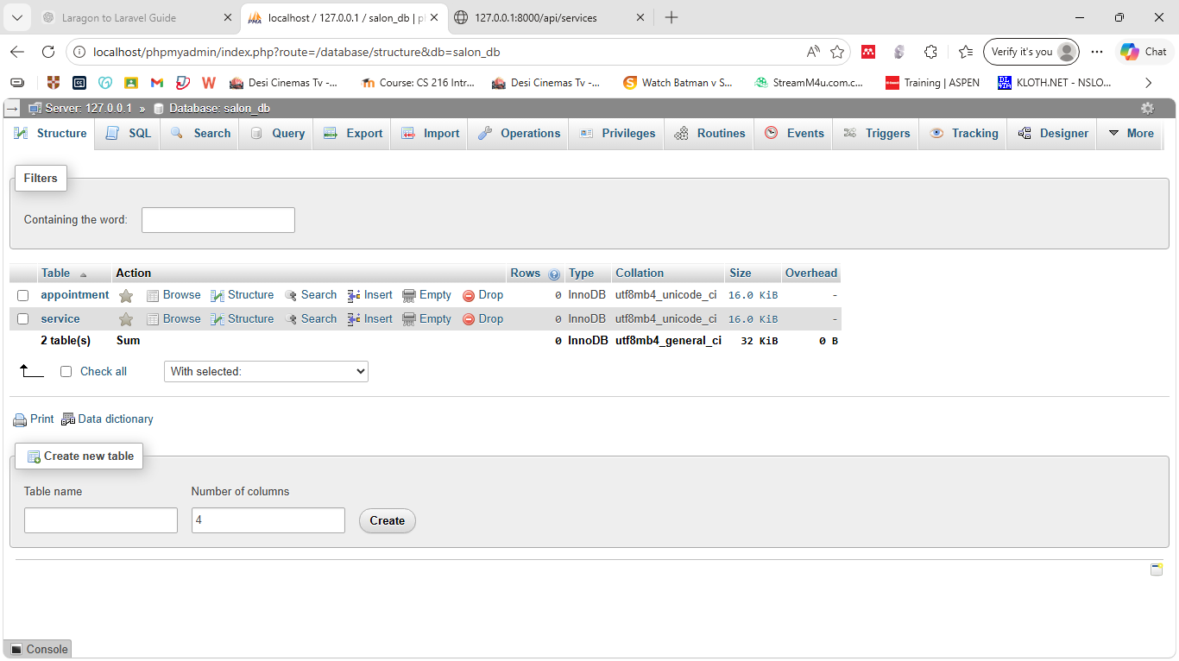

- Updating .env file (DB-DATABASE=salon_db)
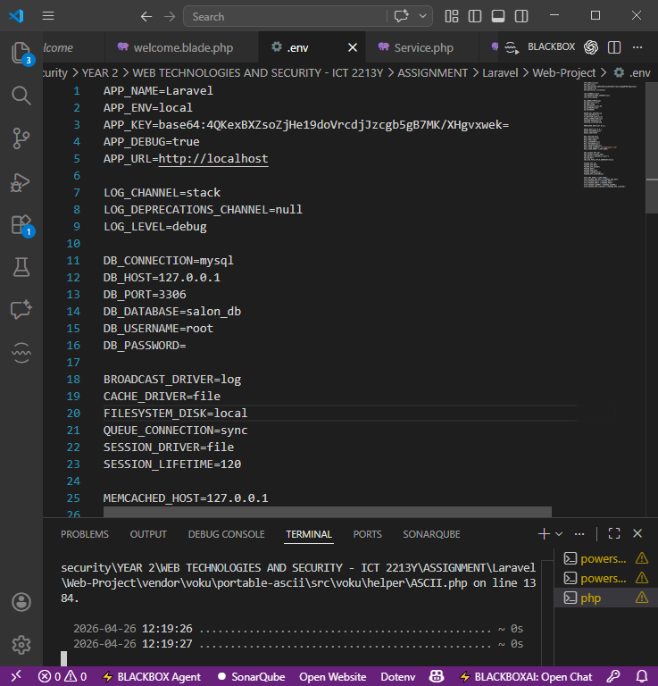

- Creating database using Migrate:

- php artisan make:migration create_appointment_table
- php artisan make:migration create_service_table

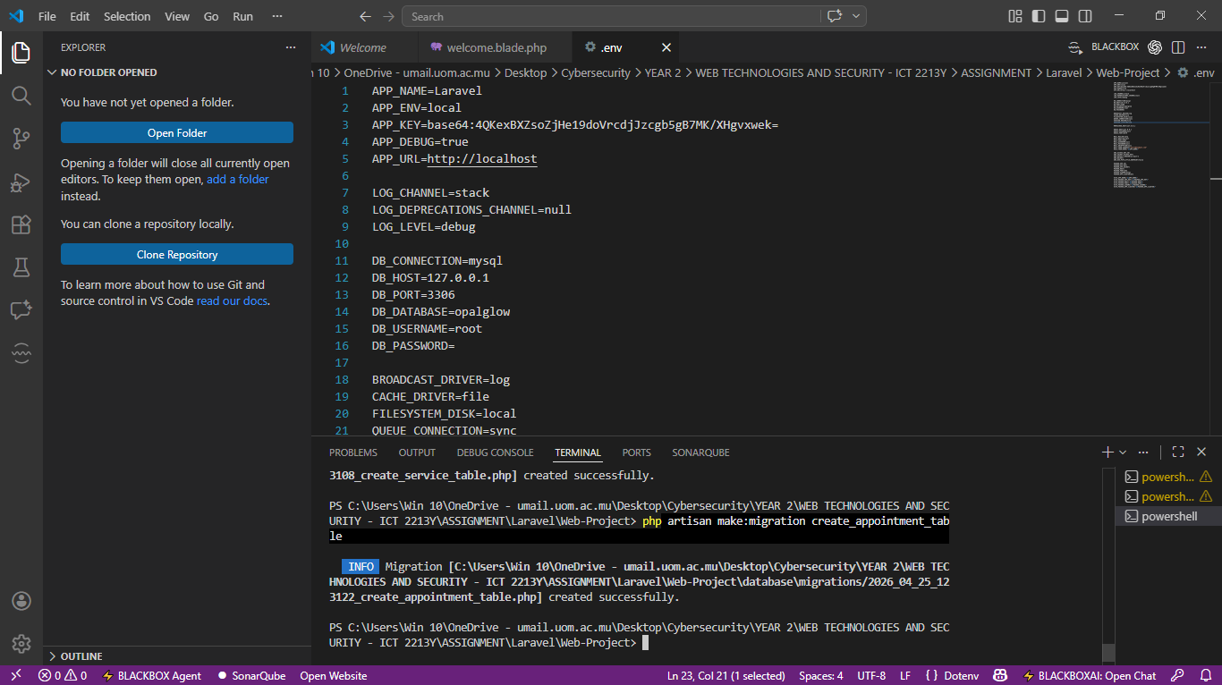

- Creating appointment table
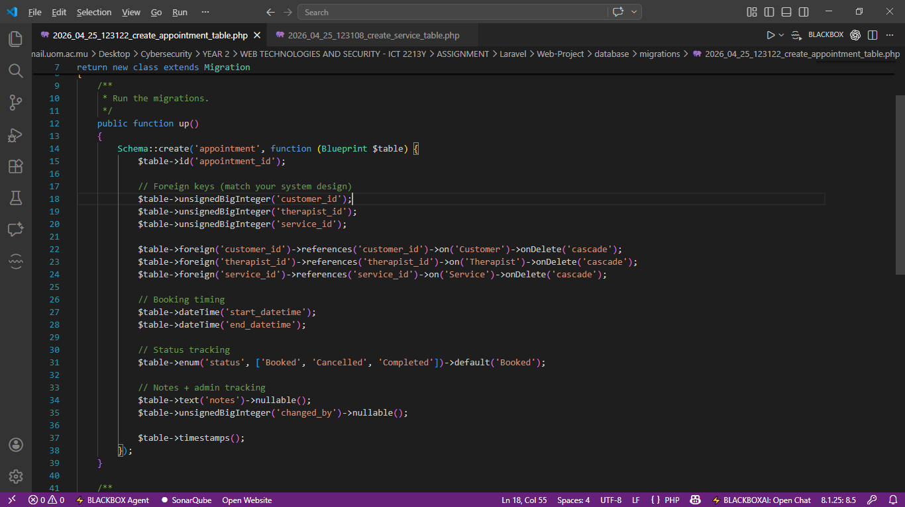

- Creating service table
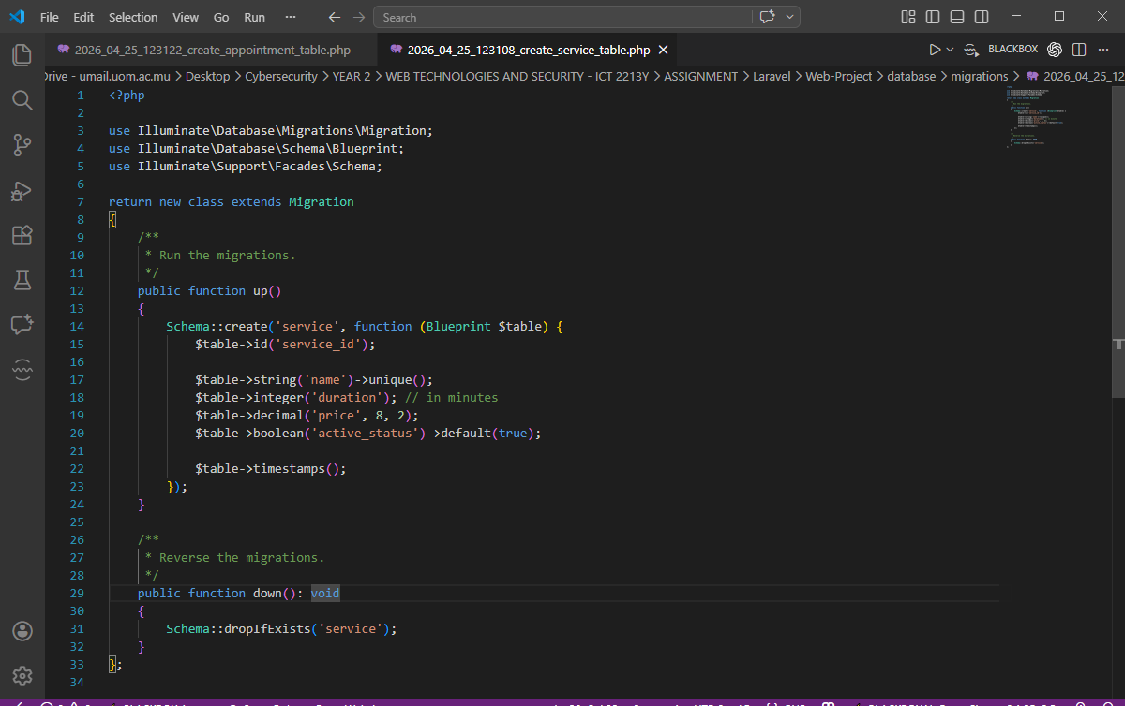

- Migrating the tables into the salon_db database
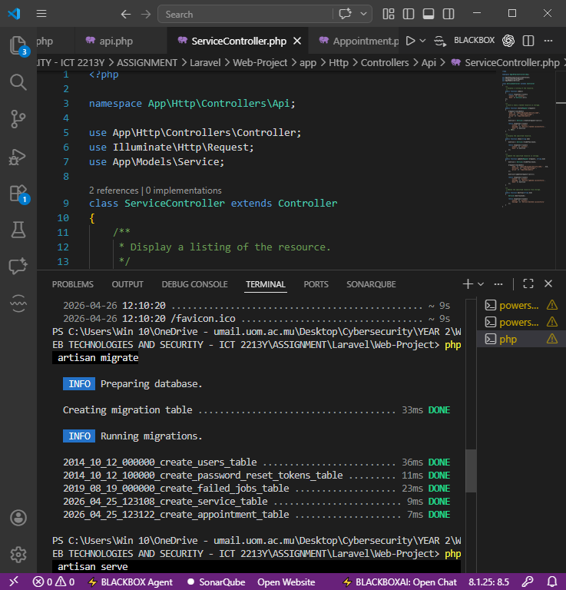
- Creating Service and Appointment php model (php artisan make:model Service)
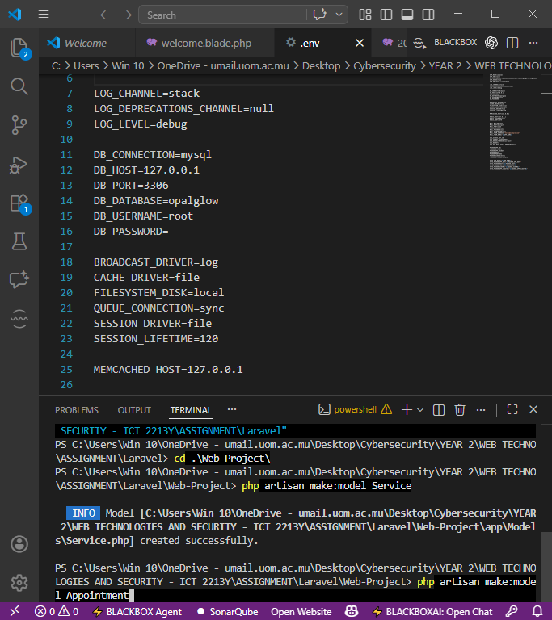

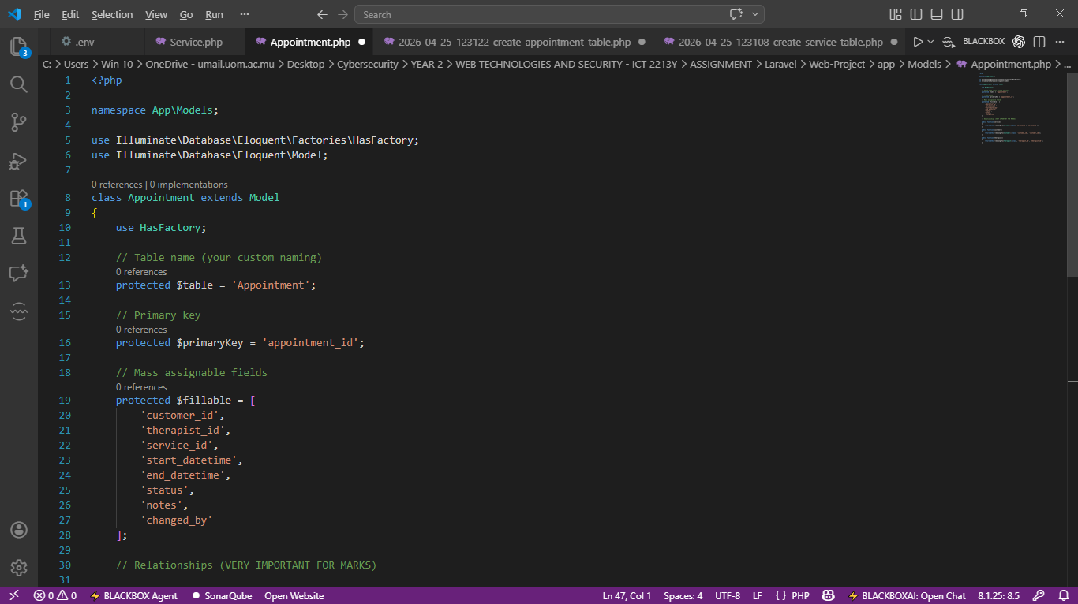
- Updating the appointment.php
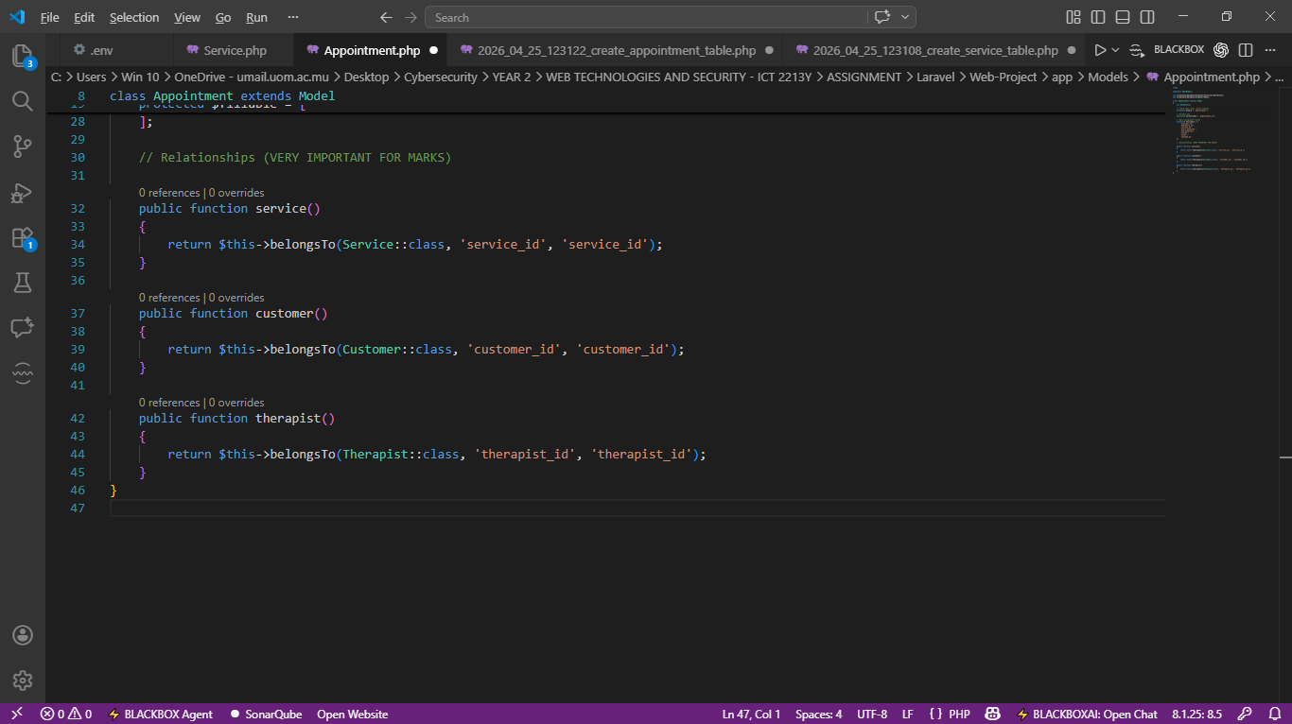

After updating, you should now have:
✔ correct table mapping
✔ correct primary key
✔ fillable fields ready for API
✔each Appointment belongs to one Customer, one Therapist, and one Service via their respective foreign keys.

- Updating the service.php
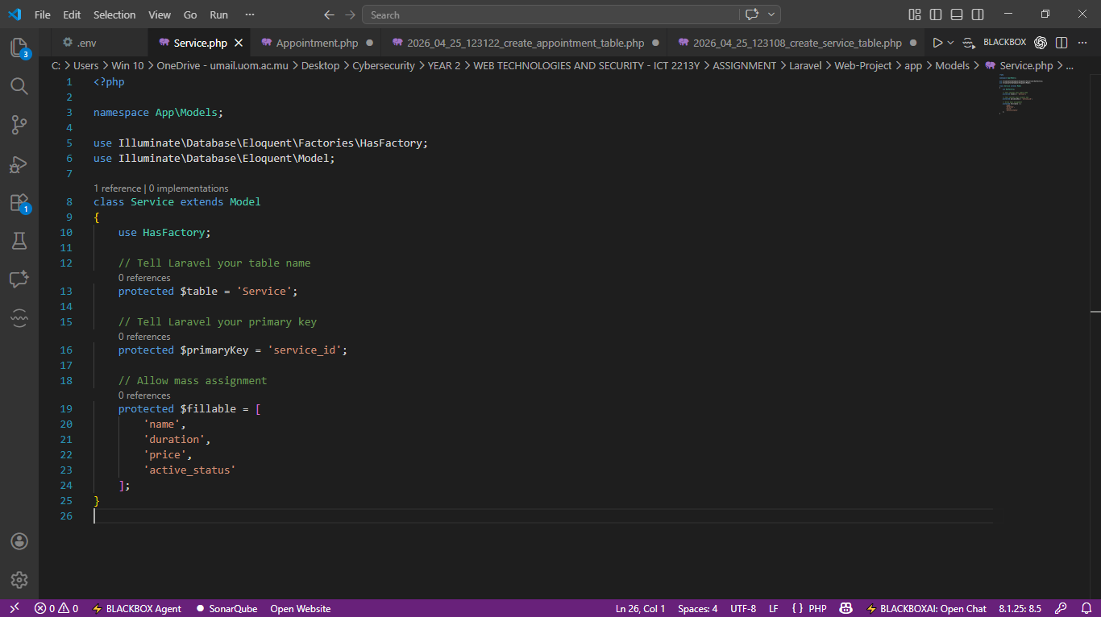
After updating, you should now have:
✔ correct table mapping
✔ correct primary key
✔ fillable fields ready for API

- Creating controller for service api
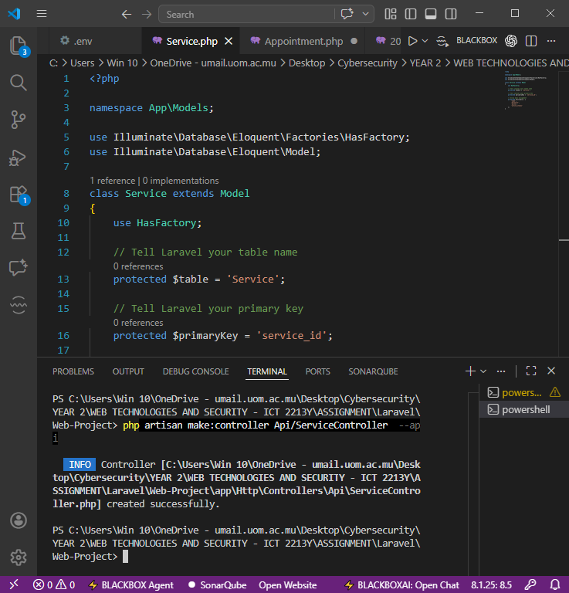

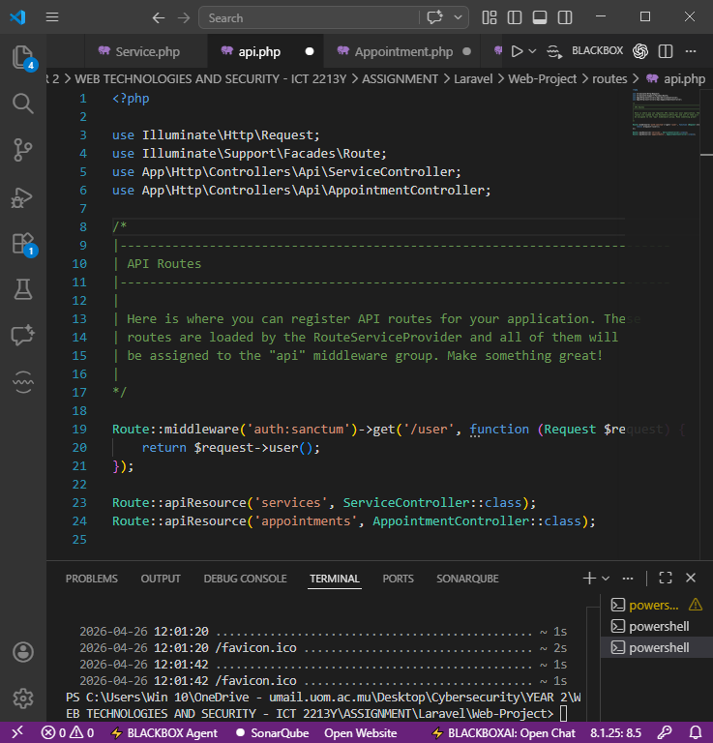
- Add API routes for service and appointment controller

- Implement Service Controller
- Get All Services Delete Service
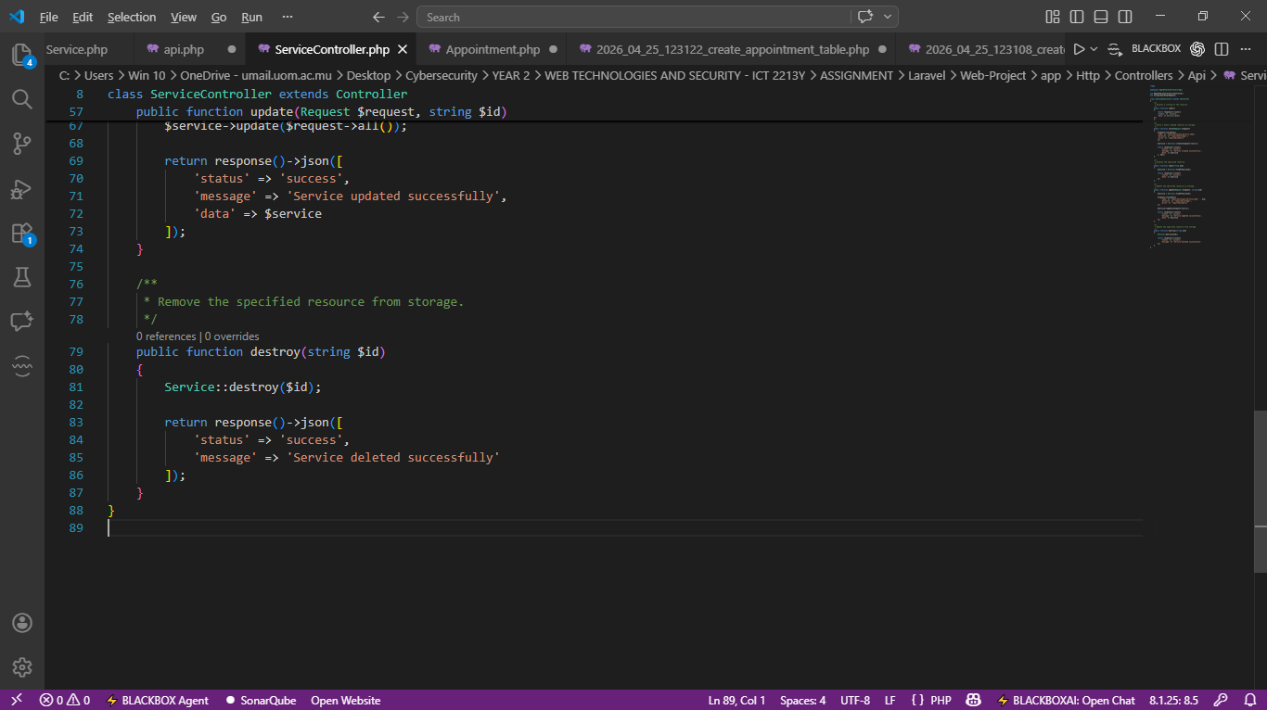
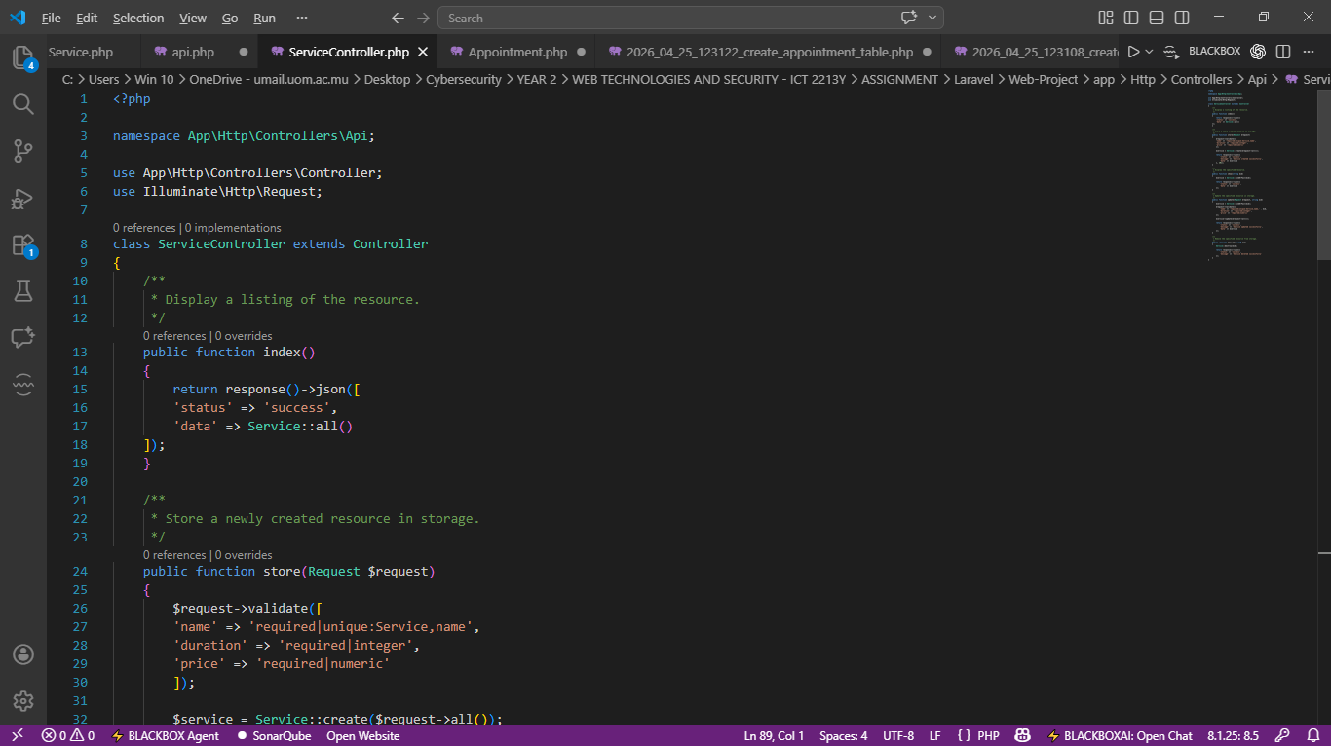

- Create Service Use App\Models\Service
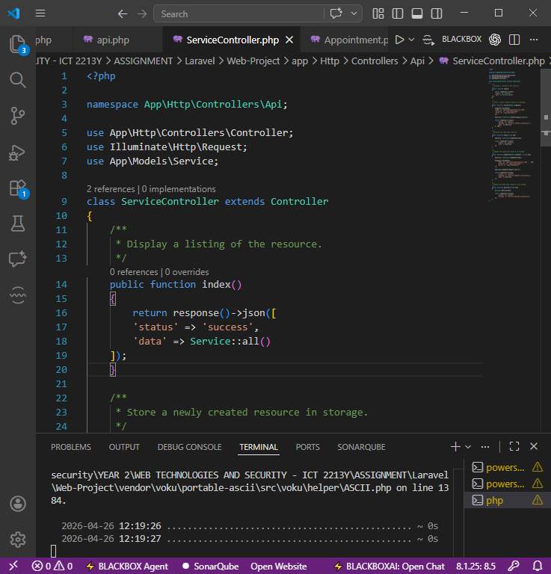
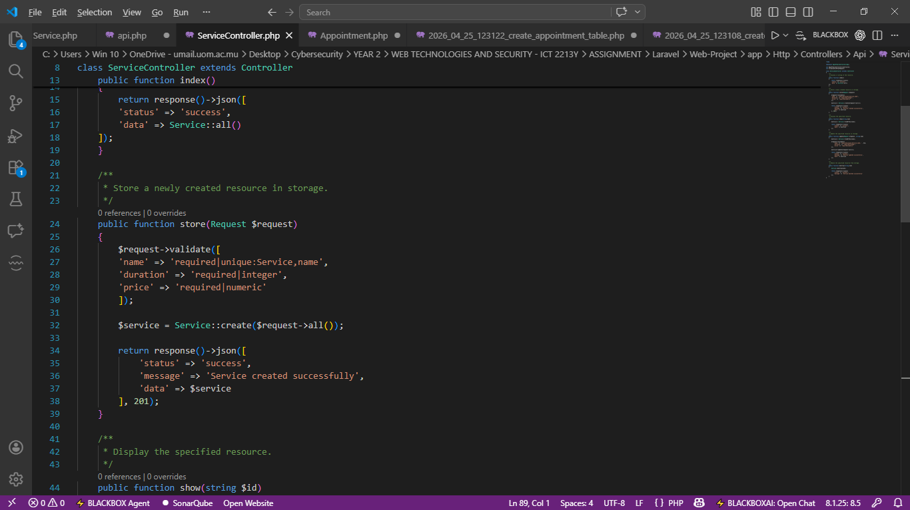

- Get Single Service
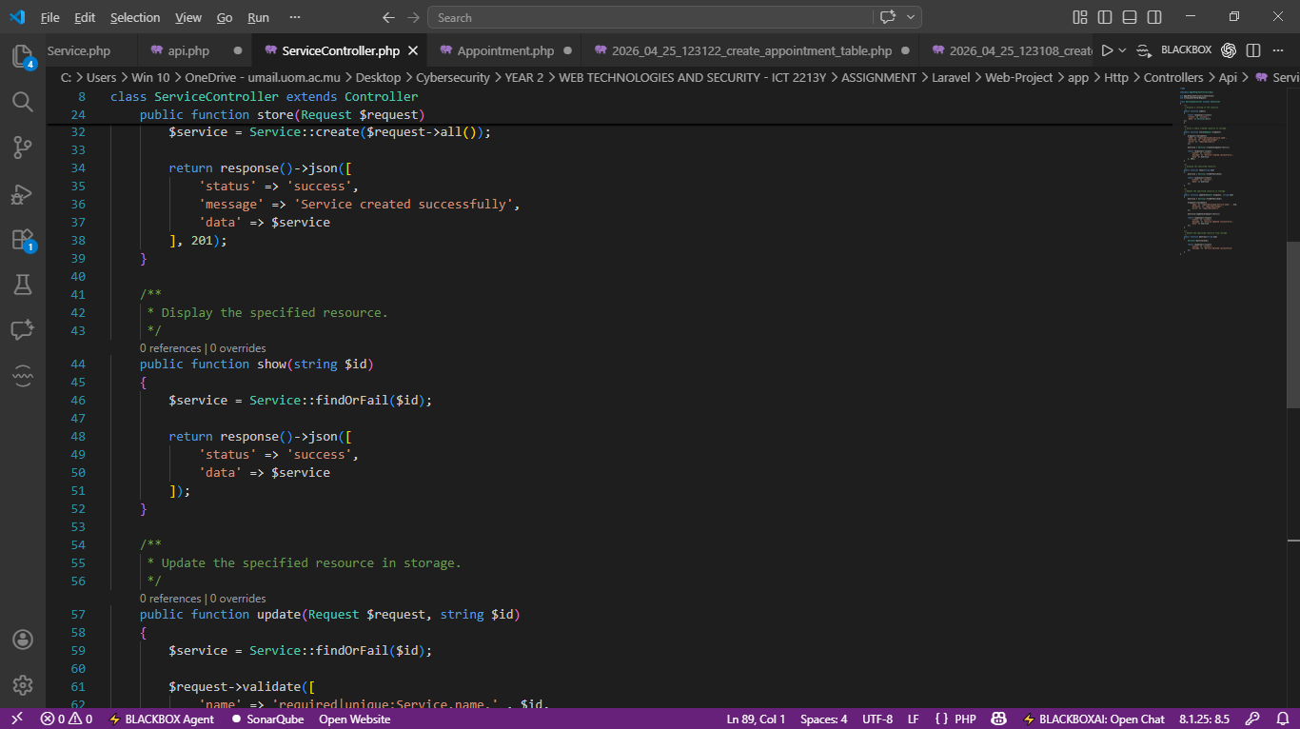

- Update Service
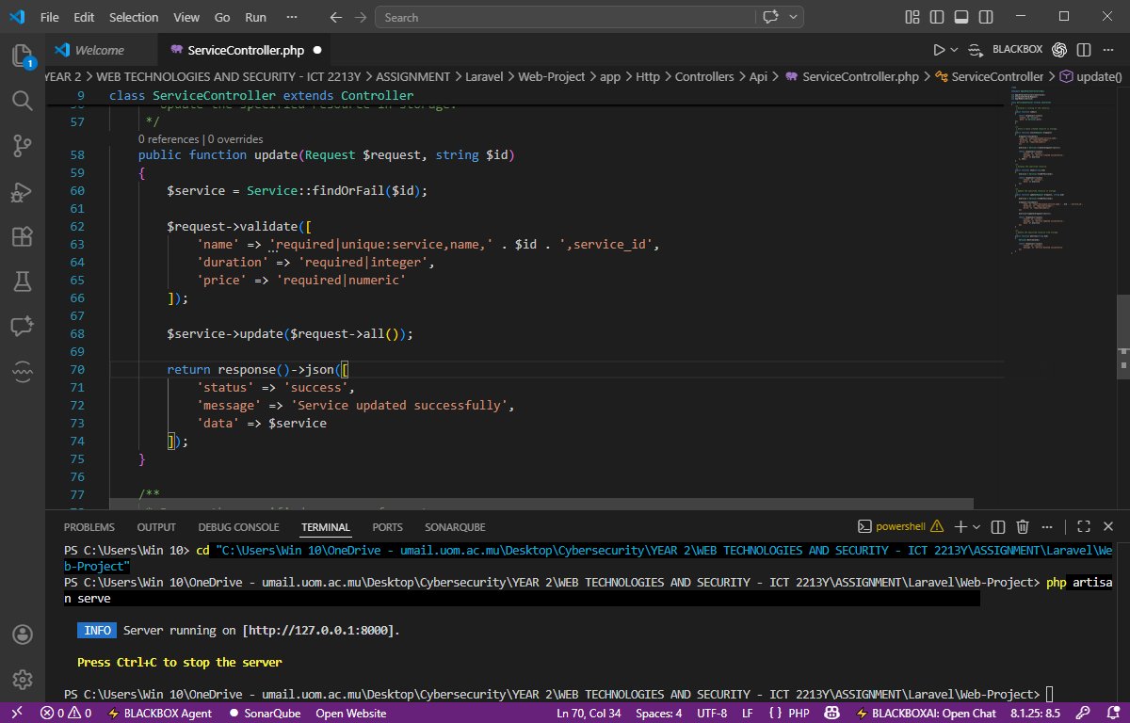

- Testing GET Request using PostMan on Services
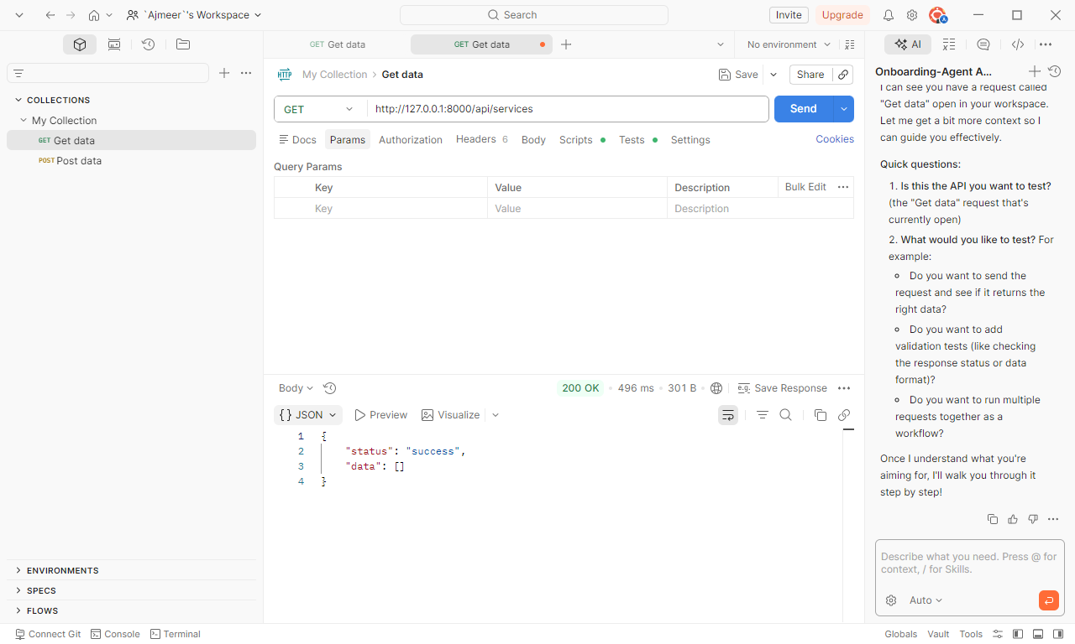

- Testing POST Request using PostMan on Services
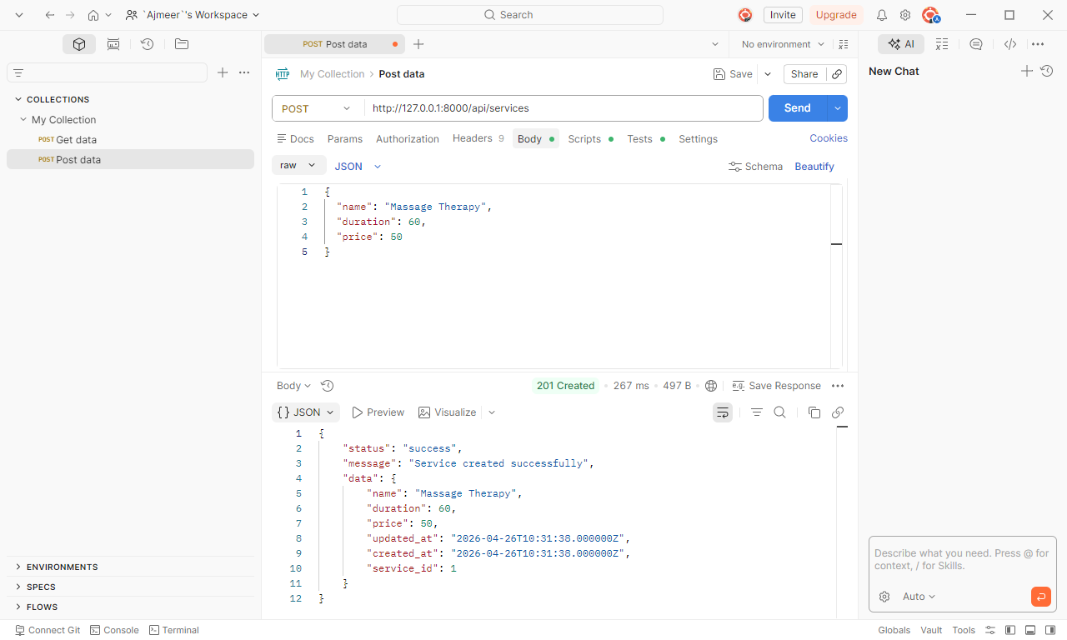

- Testing PUT Request using PostMan on Services
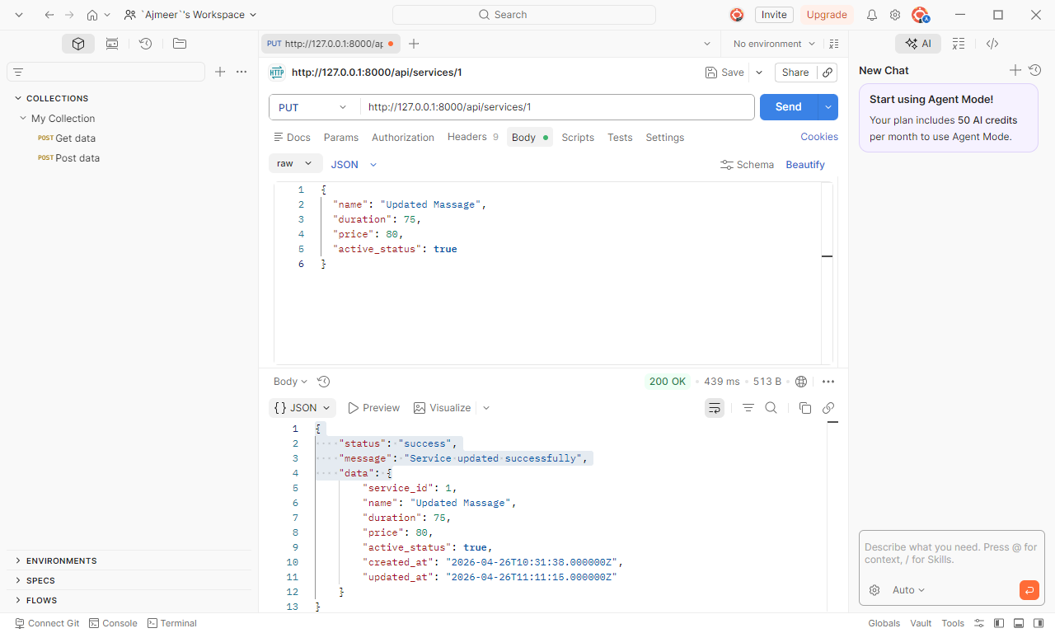

- Testing DELETE Request using PostMan on Services
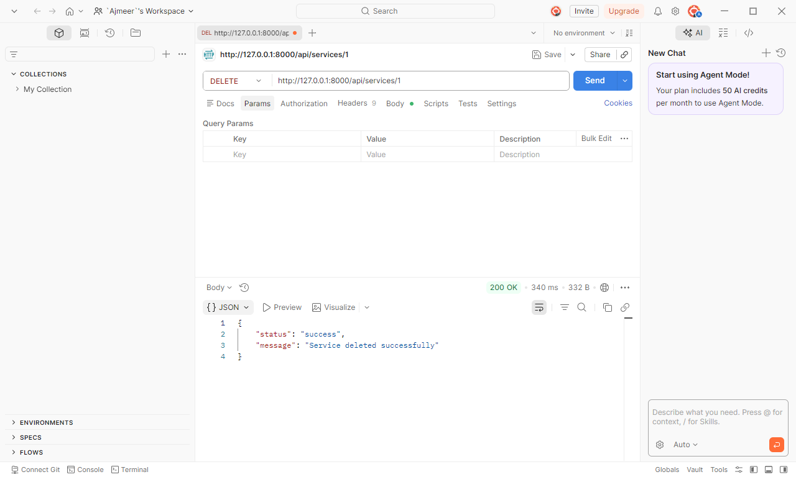

- Creating Controller for appointment api
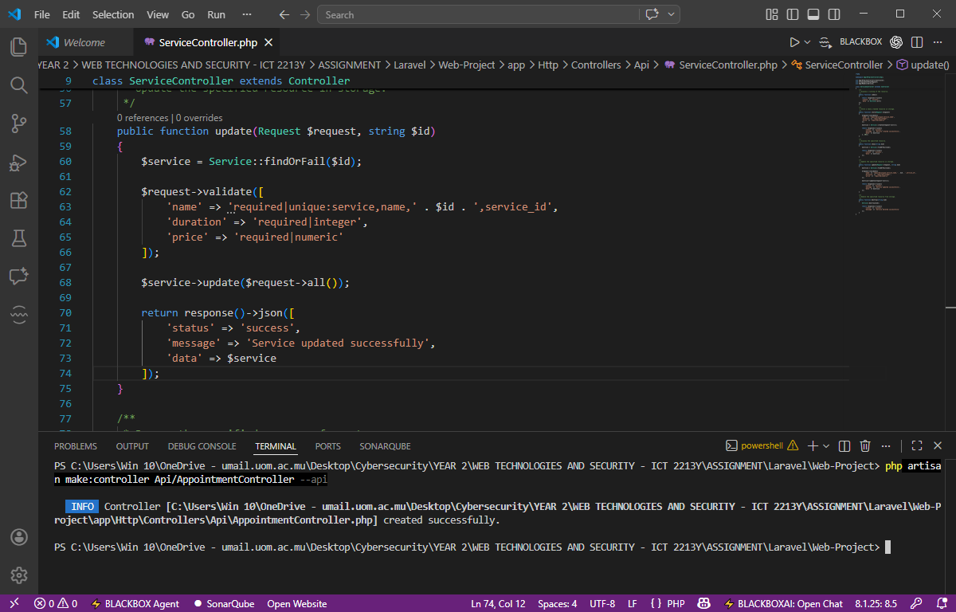

- Implement Appointment Controller
- Get All Appointments Delete Appointments
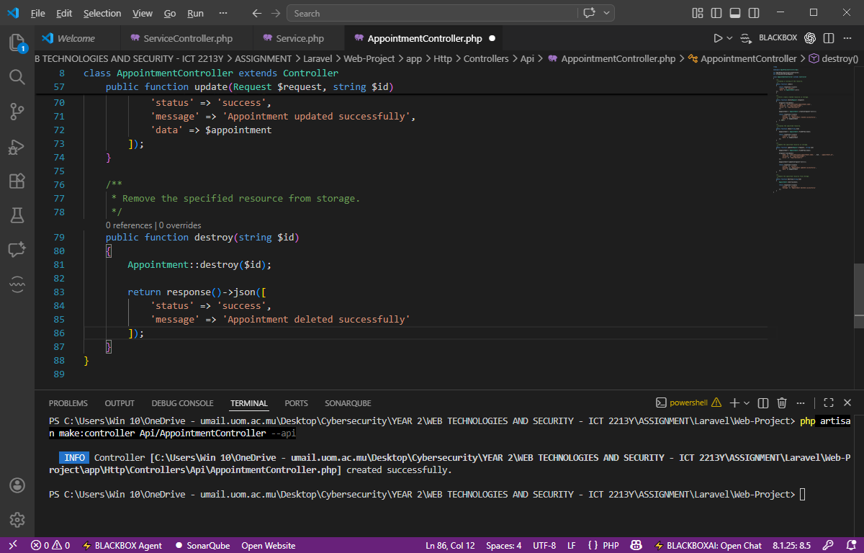
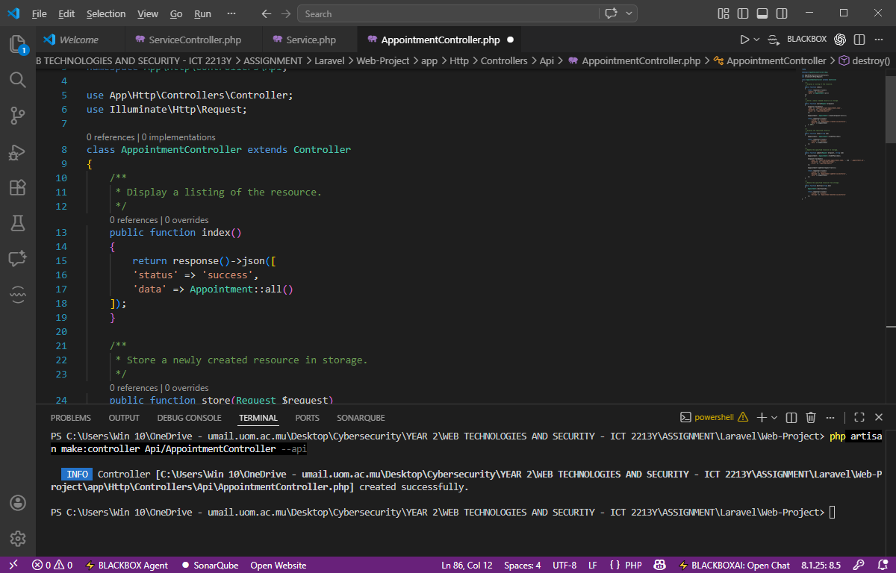

- Create Appointments
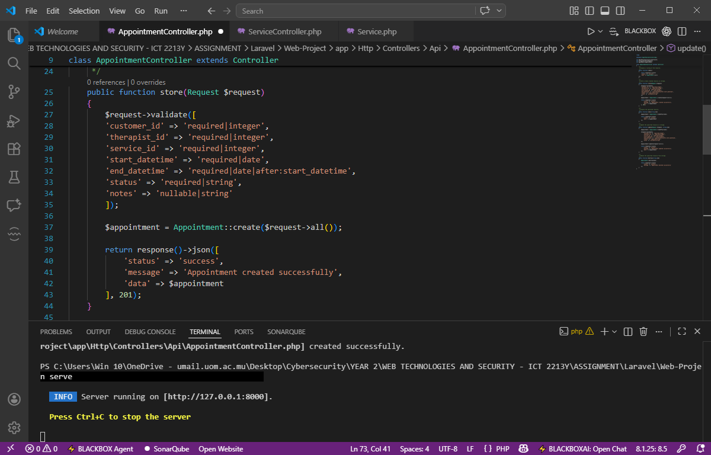
Use App\Models\
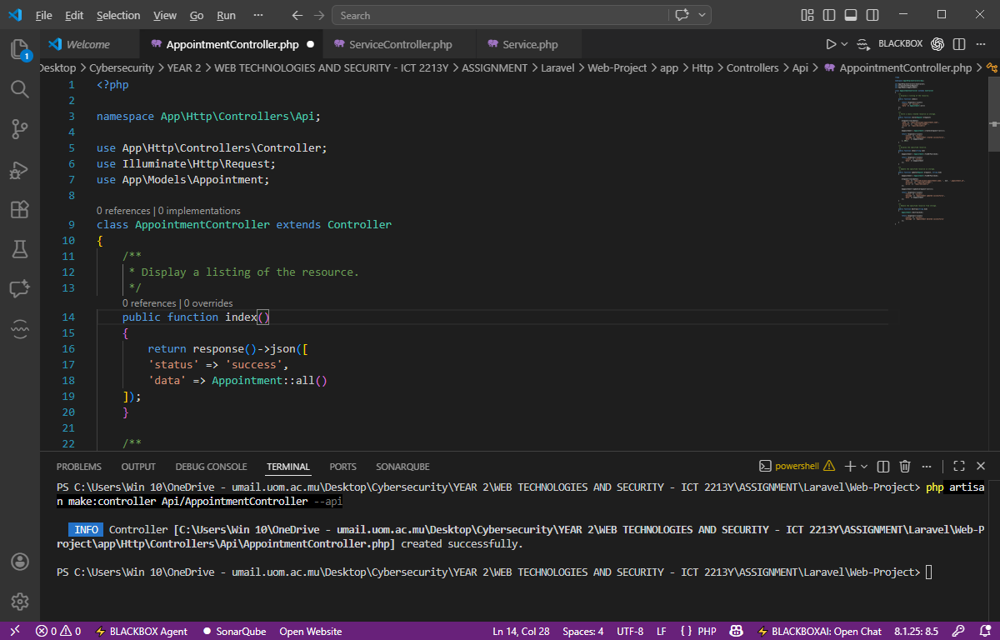

- Get Single Appointment
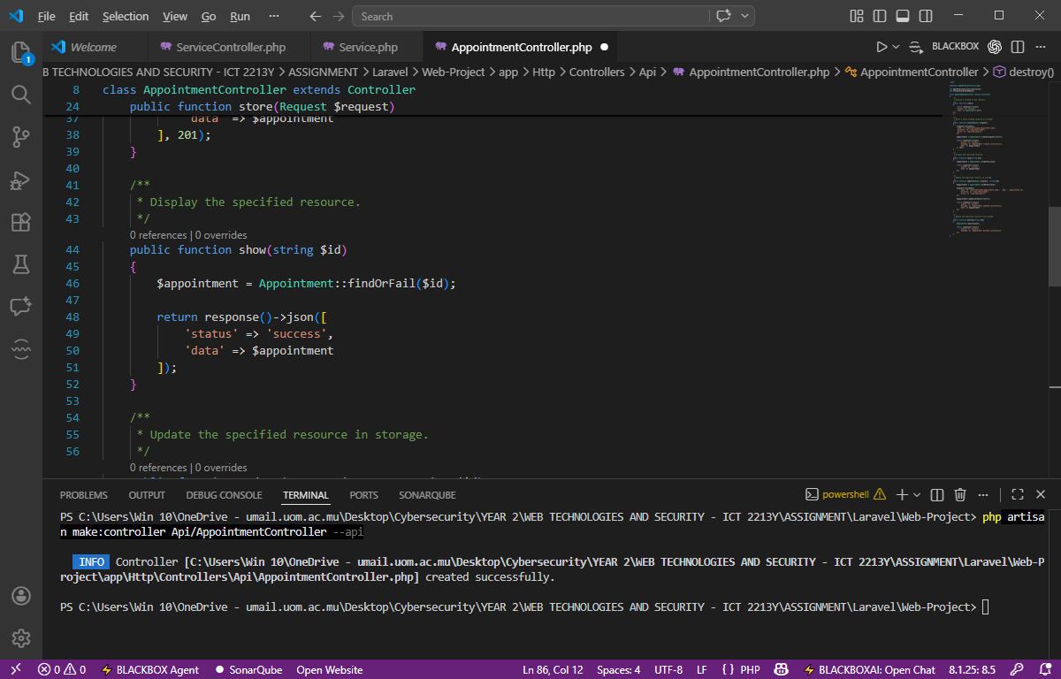

- Update Appointments
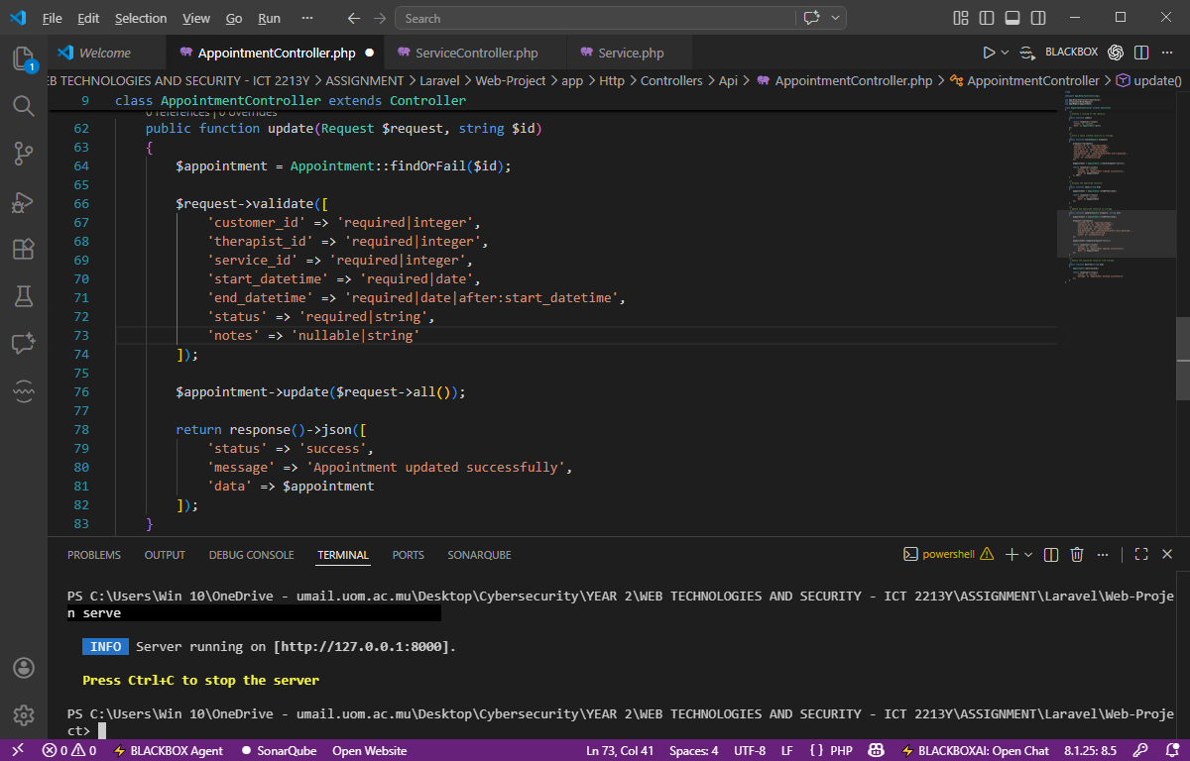
- Testing Get Request using PostMan on Appointment
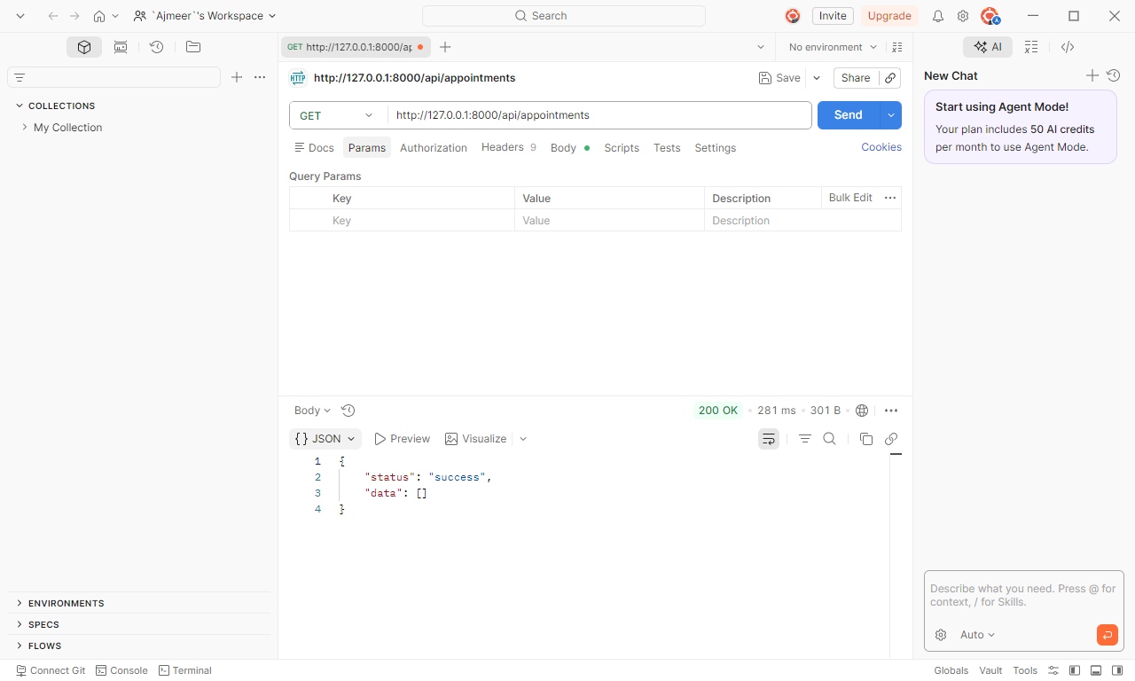

- Testing POST Request using PostMan on Appointment
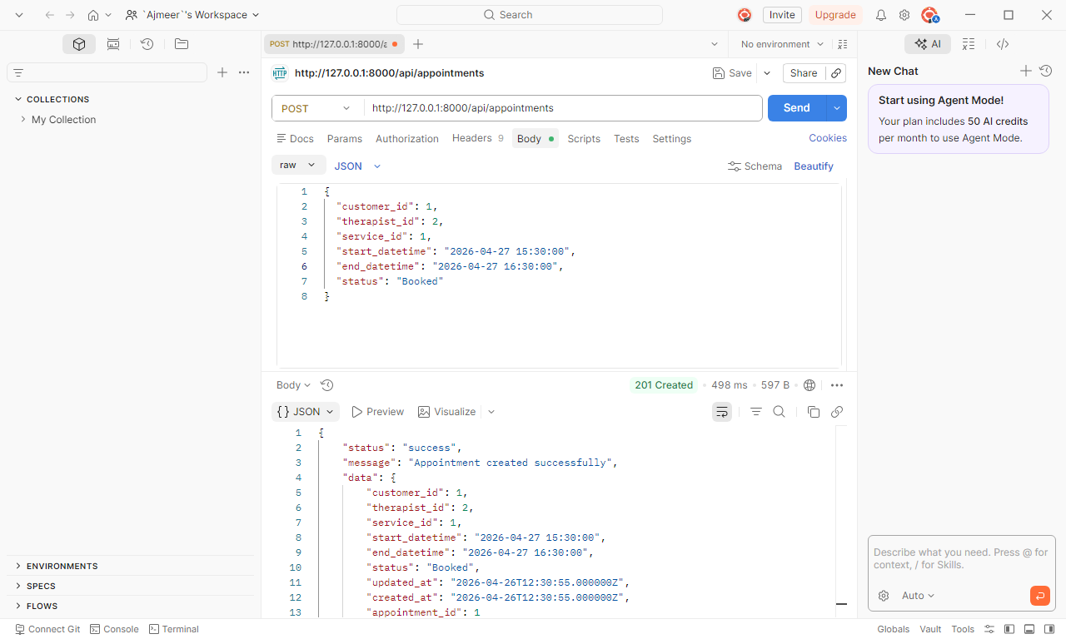

- Testing PUT Request using PostMan on Appointment
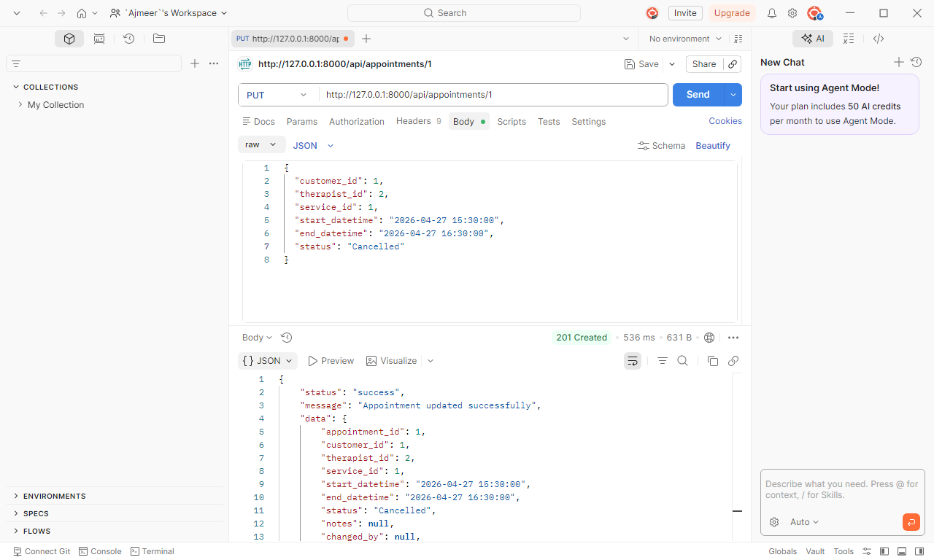

- Testing GET Request on single ID = 1 using PostMan on Appointment
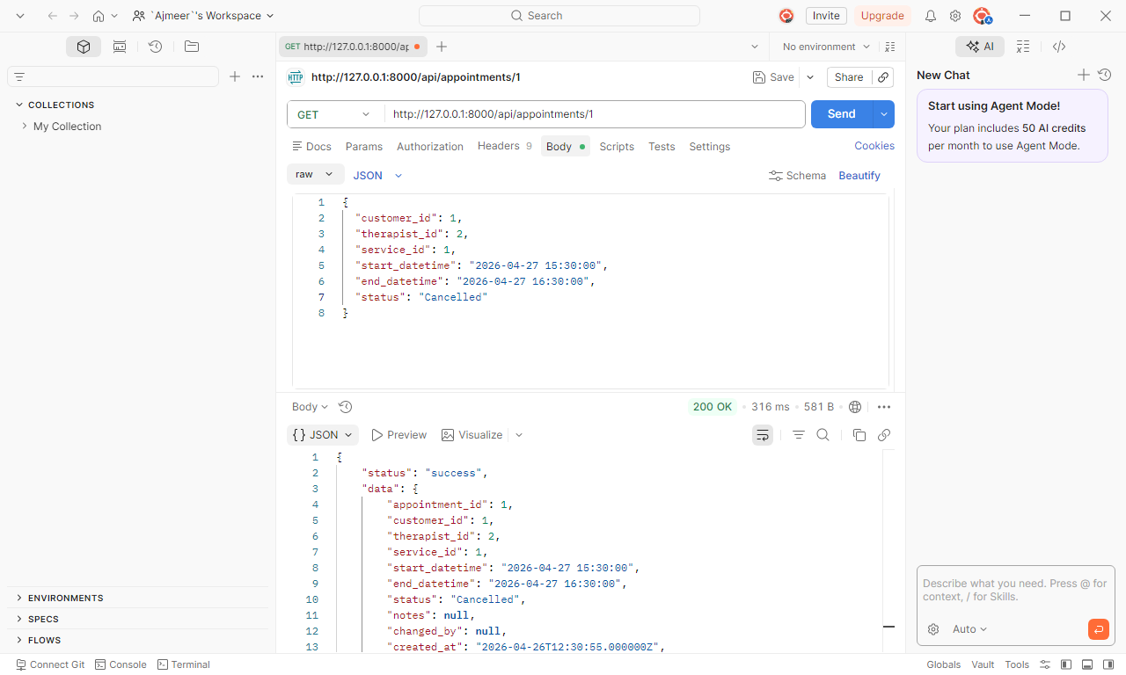

- Testing DELETE Request using PostMan on Appointment
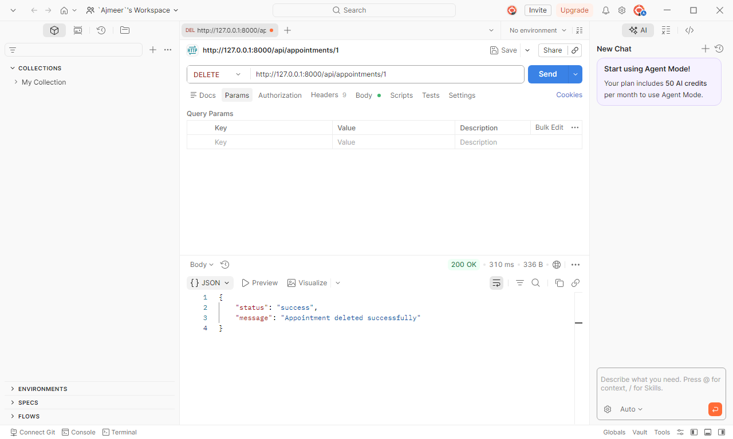

- Adding Pagination and Filter by Status in Appointment
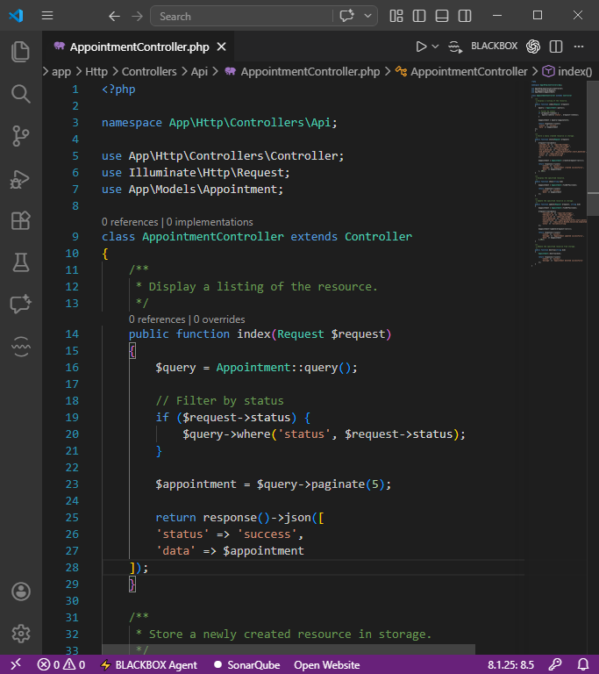
- Testing pagination using PostMan on Appointment
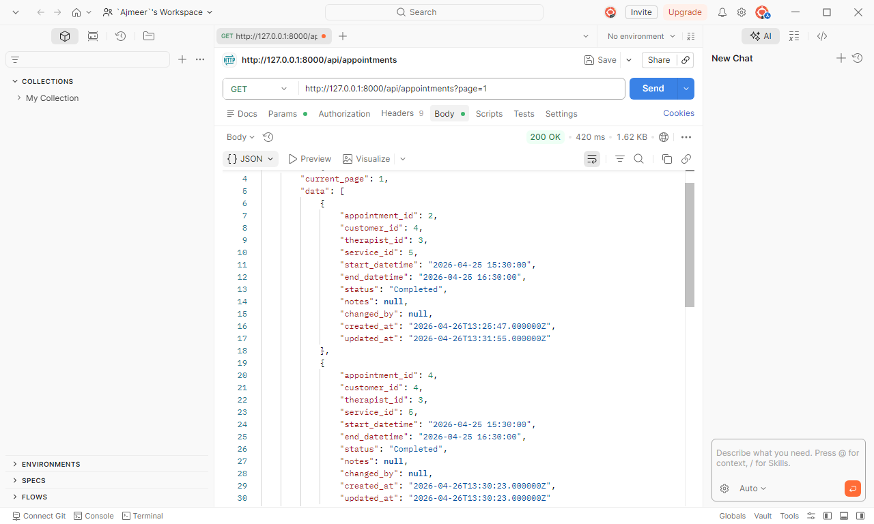
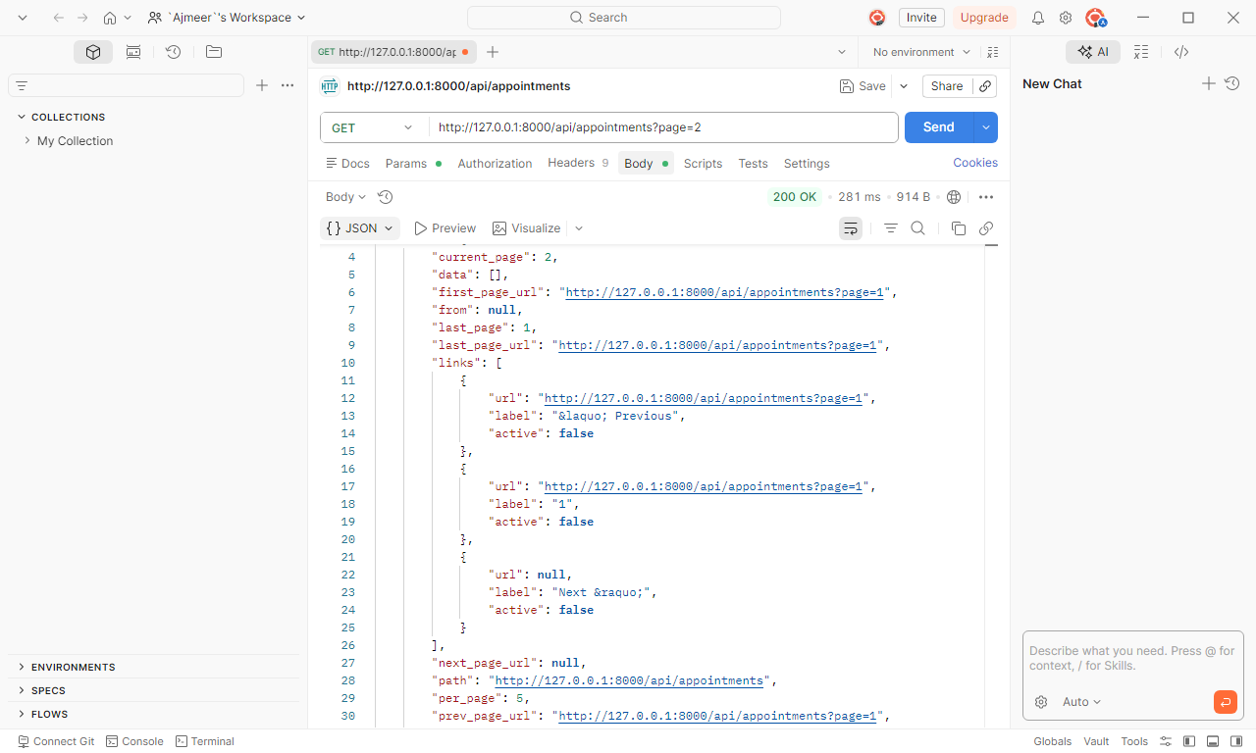

- Testing filter query by status using PostMan on Appointment
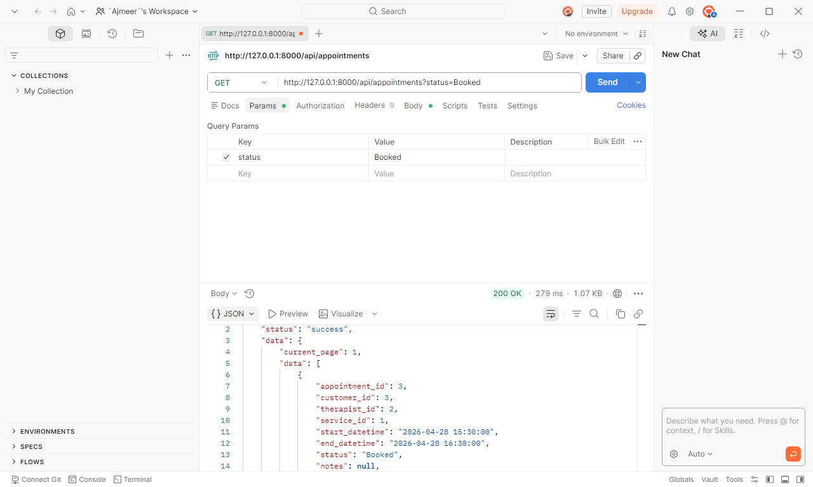

- Testing Wrong Status in PUT Method using PostMan -> Validation Error (In Postman → go to Headers
Add this: Key: Accept & Value: application/json
